Practical Multimodal Analgesia for Chronic Pain Management
Dr.G.K.Kumar,MD,DA,FIPP,
Pain consultant &Interventional Pain Specialist,
Fellow of Interventional Pain Practice (WIP-USA),
President, Indian Society for the Study of Pain,TN Chapter,
Indian Institute of Pain Management, Chennai.
Associate Professor of Anaesthesia, Govt.Aringar Anna Memorial Cancer Hospital & Research Institute.

Pain is the most common abnormal human experience. Chronic pain is a major problem in the community and understanding the chronic pain is essential for effective management. Understanding the process of the development of the chronic pain helps us to find the way to treat them effectively. Here we try to understand the methods of managing chronic pain.
What is chronic pain?
Chronic pain is often defined as any pain lasting for more than 12 weeks. Chronic pain persists—often for months or even longer, beyond the period of pathological process or injury. Whereas acute pain is a normal sensation that alerts us to a possible injury.
How is the chronic pain different from acute pain?
Acute pain might be mild and last just a moment, or it might be severe and last for weeks or months. In most cases, acute pain does not last longer than six months, and it disappears when the underlying cause of pain has been treated or has healed. Unrelieved acute pain, however, might lead to chronic pain.
Chronic pain persists despite the fact that the injury has healed. Pain signals remain active in the nervous system for weeks, months, or years. Physical effects include tense muscles, limited mobility, a lack of energy, and changes in appetite. Emotional effects include depression, anger, anxiety, and fear of re-injury. Such a fear might hinder a person's ability to return to normal work or leisure activities.
Commonly reported chronic pains are Headache, Low back pain, Cancer pain, Arthritis pain, Neurogenic pain (pain resulting from damage to nerves), Psychogenic pain (pain not due to past disease or injury or any visible sign of damage inside)
The mechanism and pathways responsible for accentuation of pain and pain reactions, referred to as sensitization, can involve increased responsivity at all levels of the pain system, including the peripheral nociceptors, the spinal cord, brainstem, and higher centers. The net effect of the positive and negative circuitry alterations leads to the characteristic experience of pain.

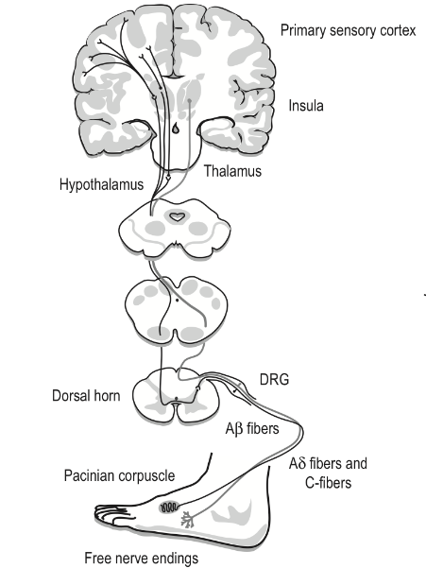The Normal Pain Pathway

The sensitization is mainly due to increased responsiveness of nociceptive neurons to their normal input, and/or recruitment of a response to normally subthreshold inputs.In chronic pain, dysregulation of one or many locations within the complex nociceptive and pain neural circuit leads to neuroplastic reorganization and increased spontaneous activity (spontaneous pain), as well as hyper responsiveness to noxious (hyperalgesia) and non-noxious (allodynia) stimuli.
The sensitization phenomenon produces,

Increased area of pain.

Increased duration of pain.

Decreased tolerability to pain.

Development of psychological problems.

Pain become non-responsive to conventional analgesics

The following are the clinical features of chronic pain also produced by the sensitization phenomenon,

Pain in the area of neuro-deficit

Allodynia

Hyperalgesia

Character of pain: Burning, shooting, electric shock-like, stabbing pain.

Associated symptoms: Numbness, tingling, pruritis, feeling of pin & needles

Sympathetic Mediated Symptoms : redness, edema, painful join movements, decreased skin temperature, fall of hairs.

Treatment Targets – AlongThe Pain Pathway

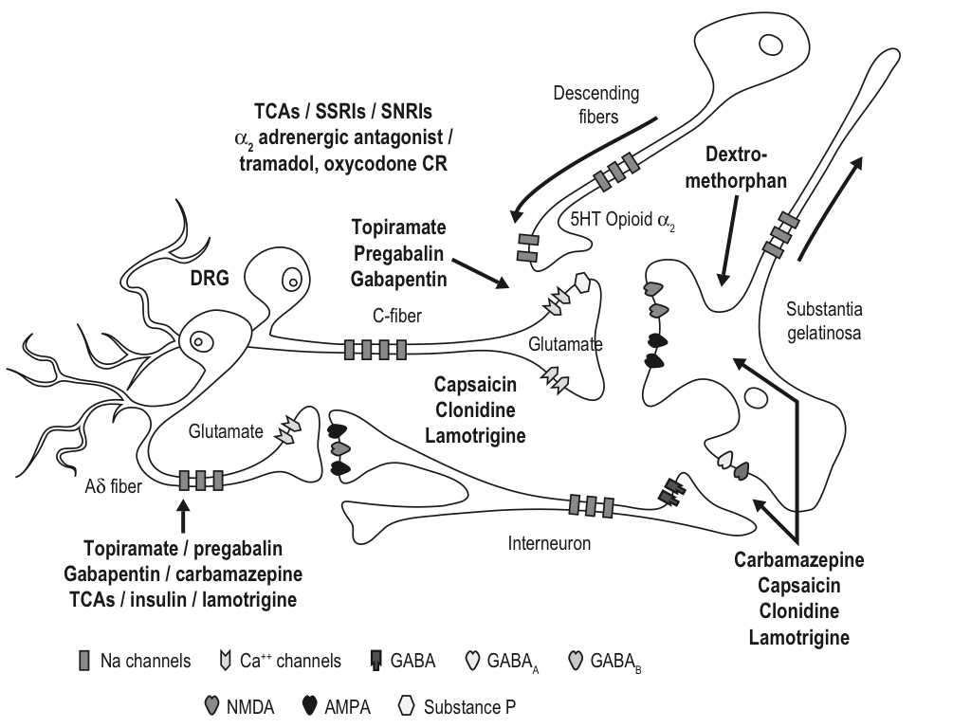
Drugs –Sites of actions

Drugs for peripheral sensitization
Na-Channel blocker, Ca-Channel blocker, NSAIDs
Drugs for central sensitization
NMDA antagonist, Ca-Channel blocker, opioids, drugs inhibiting Sub P, drugs enhances inhibitory synapses.
Restoration of descending inhibitory pathways
Tramadol, tricyclics

Hurdles of Chronic Pain Management
Successful management of chronic pain depends mainly on understanding the pathophysiological changes of chronic pain. Sensitization phenomenon that happens along the pain pathway makes regular acute pain management modalities ineffective in chronic pain.These specific pathophysiological changes are responsible for the clinical manifestations of the chronic pain syndromes.
Unaware and not understanding the specific pathophysiological features of chronic pain is the main reason for the ineffective pain management. Because of the multifaceted pathological changes, single therapeutic modality or single therapeutic method may not be effective for chronic pain. Only understanding the pathophysiological changes will help us to handle the chronic pain effectively.

Multimodal Analgesia

Chronic pain is a complex disease requiring multidimensional assessment and multimodal treatment.
Multimodal pain management was introduced in the early 1990s. This approach simultaneously administers two or more analgesic agents with different mechanisms of action. Combination therapy using drugs with distinct mechanisms of action may add analgesia or have a synergistic effect and allow for better analgesia with the use of lower doses of a given medication than if the drug were used alone.
For example, postoperative multimodal analgesia may consist of the use of opioid and nonopioid pharmacologic agents, as well as regional anesthesia and continuous peripheral neural blockade.
The multimodal approach has been endorsed by many professional organizations, including the American Society of Anesthesiologists (ASA)

What is Multimodal Analgesic Therapy?

The chronic pain is mainly managed by the following method,

1.Combination of analgesics / opioids

2.Adjuvant Pharmacologic therapy - anti neuropathic drugs

3.Interventional Pain Management Techniques

4.Physical & Rehabilitation measures

5.Psychological interventions-CBT

Pharmacologic Agents

The analgesics like NSAIDs have a limited role in chronic pain management. Unless a persistent inflammation is present in conditions like osteoarthritis knee joint, their role is very much limited.The analgesic combination with weak opioids is always useful. The choice is Tramadol & paracetamol combination.

The adjuvants
The adjuvant pharmacological agents are mainly for neuropathic pains. The commonly used drugs are,

1.Anti epileptics

Gabapentin

Pregabalin

Carbamazepine & Oxy carbamazepine

Lamotrigine

Topiramate

2.Anti Depressants

Amitriptyline

Imipiramine

Duloxetine

Milnacipran

3.Opioids

Tramadol

Tapentadol

Codeine

Morphine

Buprenorphine

4.Others

Paracetamol

Ketamine

Lignocaine

Medical Cannabis

The commonly used combinations are antiepileptic with antidepressant along with weak opioid like Tramadol / Tapendalaol. Strong opioid like morphine is still the gold standard for cancer pain management. Ketamine, Lignocaine IV are useful to treat some of the resistant pain syndromes. Medical Cannabis are yet to be widely available for clinical usage.

Interventional Techniques
Interventional techniques are not only for therapeutic use but also for diagnosis of certain chronic pains especially spinal facet joint & sacroiliac joint related pains. They also help to identify the pain generating tissues.
Commonly used interventional methods are,
- Neurolytic blocks (Fluroscope Guided / Ultrasound Guided)
- Continuous epidural / spinals
- Ozone Therapy
- Chemical ablation
- Radiofrequency lesioning
- Spinal Cord Stimulators
- Intrathecal drug delivery systems / Implanted pumps
8.Prolotherapy- injecting drugs like Platelet rich plasma
The radio-frequency ablation of pain generating neural tissues are very much effective in treating trigeminal neuralgia, chronic spinal pains, cervical & lumbar spinal facet joint arthropathy, chronic pancreatitis pain, chronic pelvic pains, cancer pains,CRPS, Sympathetic mediated pains.
The chemical neurolysis of nerves/plexus like coeliac,hypogastric plexus with alcohol/phenol are mainlyfor managing cancer pains.
The ozone injection & prolotherapy are mainly useful for Myofascial pains, plantar fascial pain, soft tissue pain, arthritis pain.
The spinal cord /peripheral nerve stimulators, intrathecal pumps are useful for some of the resistant pain syndromes.

To conclude,
1.Multimodal approach is necessary for chronic painmanagement
2.Interventional pain management techniques works in most of situations & also improves the quality of pain relief.
3.Combination of analgesic medications are very useful in treating mild to moderate chronic pain.
4.Adjuvant antineuropathy medications are necessary in most cases
5.Physiotherapy & rehabilitation too are essential .

References
1.The Role of Intravenous Acetaminophen in Acute Pain Management,A Case-Illustrated Review Chris Pasero, MS, RN-BC, FAAN; Daphne Stannard, PhD, RN, CCRN, CCNS, FCCM
2. ASA Task Force,( 2012), the American Pain Society (APS) (APS, 2008), and the American Society for Pain Management Nursing (ASPMN) (Jarzyna et al., 2011)
3.CharlesE.Argoff et al , Multimodal Analgesia for Chronic Pain:Rationale and Future Directions,Journal Pain Medicine, Volume 10.Number S2.2009
4. Raj’s Practical Management of Pain , 4th Edition
5.Clifford J Woolf, Central Sensitization : Implications for the diagnosis and treatment of pain,Pain,2011,March,152
6.AsokkumarBuvanendran, Multimodal Analgesia for Perioperative Pain Management, International Anesthesia Research Scociety,2011
7. For further communications drkumargk@gmail.com, www.painclinicchennai.com

